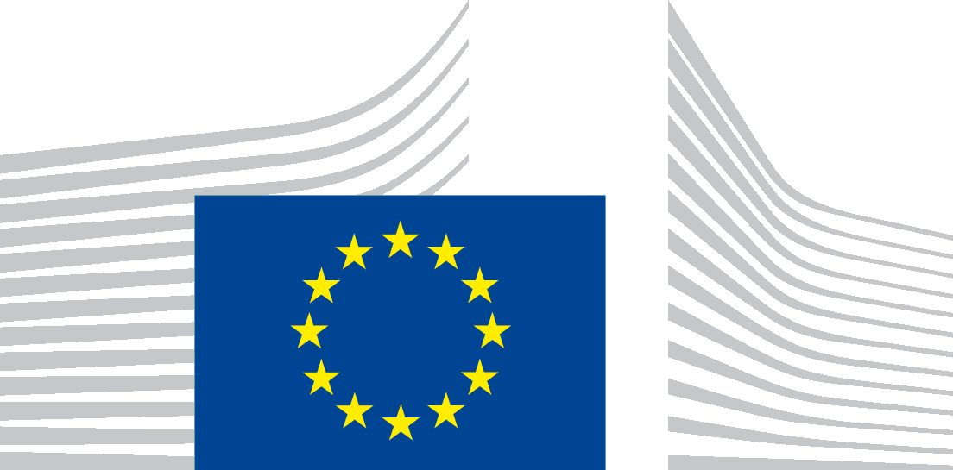 | EUROPEAN COMMISSION  DIRECTORATE-GENERAL FOR AGRICULTURE AND RURAL DEVELOPMENT  Directorate B. Quality, Research & Innovation, Outreach  B.4. Organics

28 November 2018

Guidelines
on additional official controls on products originating from China

Applicable from 01/01/2019 until 31/12/2019

This document has been conceived as a working document of the Commission Services. It has been elaborated in co-operation with the member States. It does not intend to produce legally binding effects and by its nature it does not prejudice any measure taken by the Commission or by a Member State within the implementation prerogatives under Article 32 and 33 of Council Regulation (EC) No 834/2007 and of Commission Regulation (EC) No 1235/2008, nor any case law developed with regard to these provisions.

Guidelines on additional official controls on products originating from China
Applicable from 01/01/2019 until 31/12/2019

The Competent Authorities of all Member States undertake to ensure that the control measures described in these guidelines are carried out on all consignments of organic food and feed originating from China with the following CN-codes:
  - Chapter 10 – Cereals
  - Chapter 11 – Products of the milling industry; malt; starches; inulin; wheat gluten
  - Chapter 12 – Oil seeds and oleaginous fruits; miscellaneous grains, seeds and fruit; industrial or medicinal plants; straw and fodder (including 12.06 - Sunflower seeds)
  - Chapter 23 – Residues and waste from the food industries, prepared animal fodder (including 23.06 - Oilcake and other solid residues, whether or not ground or in the form of pellets, resulting from the extraction of vegetable fats or oils, other than those of heading 2304 or 2305)
as well as on the following product:
  - Goji berries (Lycium barbarum and Lycium chinense) and products processed from them.
Consignments originating from China arriving at the EU border from another third country shall also be concerned by these guidelines.

The Competent Authorities will only endorse the Certificate of Inspection, allow these consignments to leave the premises of the first consignees and allow these products to be put on the market as being an organic product when the control measures set out in sections (2) and (3) of these guidelines have been carried out under their responsibility and have been concluded with satisfactory results.

(1) Tracking and identification of all consignments of imported food and feed
The Competent Authorities shall track and identify all consignments of food and feed defined above.
Moreover, as set out in the first subparagraph of Article 84 of Regulation 889/2008, the importer shall in due time inform the control body or control authority of each consignment to be imported into the European Union.

(2) Complete documentation check at point of entry
The complete documentation of these consignments shall be verified systematically:
- Certificate of inspection
- Documents of custom declaration
- Transport documents
- Operators and product traceability: verification of names, addresses and valid certification of each operator involved, from farmer(s) to exporter and all operators in between, including traders.

(3) Sampling and analysing for presence of pesticide residues each incoming consignment at point of entry
At least 1 representative sample shall be taken of each of these consignments at the point of entry in the EU. Sampling shall be done by using the methods as described in Commission Regulation (EU) No 691/2013 on the sampling methods to be used for official control of feed.
These samples shall be analysed for the presence of pesticide residues in an accredited laboratory. The analytical methods to be used should cover all the relevant pesticides, as defined by expert knowledge.
The sampling report of each sample must contain the identification of the consignment: lot number and, when available, number of the Certificate of Inspection.
When pesticide residues or other irregularities are detected, an investigation shall be started and a notification in the Commission's Organic Farming Information System (OFIS) shall be made.

The authorities designated pursuant to Art. 27(1) of Regulation (EC) No 834/2007

